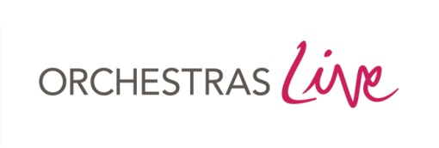
OL Ref:

ACTIVITY NOTIFICATION FORM 2021/22

Please complete and submit a copy of this form for each event/project. It should be returned to Orchestras Live as soon as the information is available and at least three months before the activity is due to take place. For projects please also provide a full schedule of activity and a project budget.

Crediting requirements: The following wording must be used in all publicity ‘This event/project has been produced with/co-produced with/achieved in partnership with Orchestras Live’. [Delete as appropriate.] This is the minimum level of accreditation required as a condition of your partnership with Orchestras Live.

In addition, the Orchestras Live logo, Arts Council England logo and any other relevant financial supporters/sponsors of Orchestras Live must be included in all publicity for the event. These can be found at http://www.orchestraslive.org.uk/partner-resources

Funding Allocations: Funding must be claimed within 4 weeks of the activity taking place. Allocations are in the form of a grant, which does not attract VAT, and these funds are only payable if this event makes a financial loss.

Name and address of partner
Contact Name & email/phone
Orchestra
Date and Time of event(s)
Project name/description
(if applicable)

WORKSHOP DETAILS (if applicable)
Venue
(Name, address and postcode)
Workshop Details
(please provide a separate schedule if necessary)

EVENT DETAILS (if applicable)
Venue
(Name, address and postcode)
Details of pieces to be performed:
Web link for booking tickets
(if applicable):

FUNDING ALLOCATIONS
OL funding source | Organisation which has Partnership Agreement with Orchestras Live |  |  | Allocation
Partnership Fund |  |  |  | £
Programme Funding from Orchestras Live |  |  |  | £
 |  |  | TOTAL GUARANTEE AVAILABLE * | £

* Please note that these fund allocations are a guarantee against loss for this event.

DECLARATION

I have noted and agree to comply with the crediting and funding requirements listed above
Name |  | Date
Signature

Please e-mail completed notification form or any questions about this form to: tom@orchestraslive.org.uk

